David Terkula

Development Graph Analysis

Economics 346

4/1/17

What Factor Contribute to Brain Drain?

The selected graph plots countries of based on the percent of their GDP devoted to R&D versus the number of researchers per 1 million people. Each country shown has other data associated with it, such as university rankings, percentage of researchers that are foreign, percentage of people that are emigrants in the country, and various other statistics that are shown on the graph’s legend. By examining all the factors that this graph displays at one time, an understanding of the phenomenon of “brain drain”, or the emigration of highly trained or intelligent people from a country, can be obtained. Brain drain can hinder a country’s ability to develop economically because skilled and talented individuals leave the country, some never to return, which negatively impacts growth in the worker’s country of origin. The following analysis seeks an understanding of what factors push or pull skilled and intelligent workers to leave their homeland, and what actions countries can take to abate this effect.

Perhaps the country represented on the graph which presents the clearest effect of brain drain is India. India is in the bottom left-hand corner of the graph, which means it has the lowest number of researchers per million and the lowest percentage of is GDP devoted R&D. As shown by the graph, India send almost all of its emigrants to the United States, which is in the group of countries with higher R&D and researchers per million. Not only are the skilled and intelligent Indian migrants moving to countries with more researchers and R&D, but also to a country with some of the highest university rankings of the selected countries. If an Indian wanted to study and surround him or herself with highly regarded institutions and other researchers, the Indian would seemingly have to travel north-east up the graph, since India has the lowest rated universities and number of researchers shown on the graph. The lack of highly regarded research institutions acts as a push and a pull factor for highly skilled Indians to and from the country, as they are pulled from countries with better institutions and higher wages/returns for their labor and are pushed away from an absence of R&D in general.

Because of India’s lack of R&D and research institutions, there is also a lack of foreign researchers coming in. India is one of the few countries on the graph that has no dashed line leading to it, and it has almost no foreign researchers in the population. Thus, the flow of highly skilled labor out of the country is purely negative robs India of its skilled labor and the improvements to the society that could be made through the employment of their talents. However, there is a bright spot for India, and that is the percentage of emigrant researches returning to their country of origin at some point, which is on par or even better than some countries in the devolving world. This ‘reverse’ brain drain effect cancels out some of the negative flow of skilled labor from the country, but still leaves the country in a deficit of skilled labor.

By examining the graph, some policy solutions to India’s brain drain problem become clear. The countries in the north eastern part of the graph invest more of their GDP in R&D and they have higher ranked universities. Emigrant researchers across the graphed countries move from low ranking universities to higher ranked universities (or of equal rank), and/or to countries that invest more in R&D. If India invested more in its universities and in research in development, then one could expect less of their researchers to leave the country, more would return, and perhaps even attract some researchers from other countries (but perhaps from those not graphed). However, brain drain is perhaps not the first issue policy makers in India will attend to, as there are millions of people living in abject poverty. However, eventually the country will need to address this problem as it develops further and the demand for skilled labor increases.

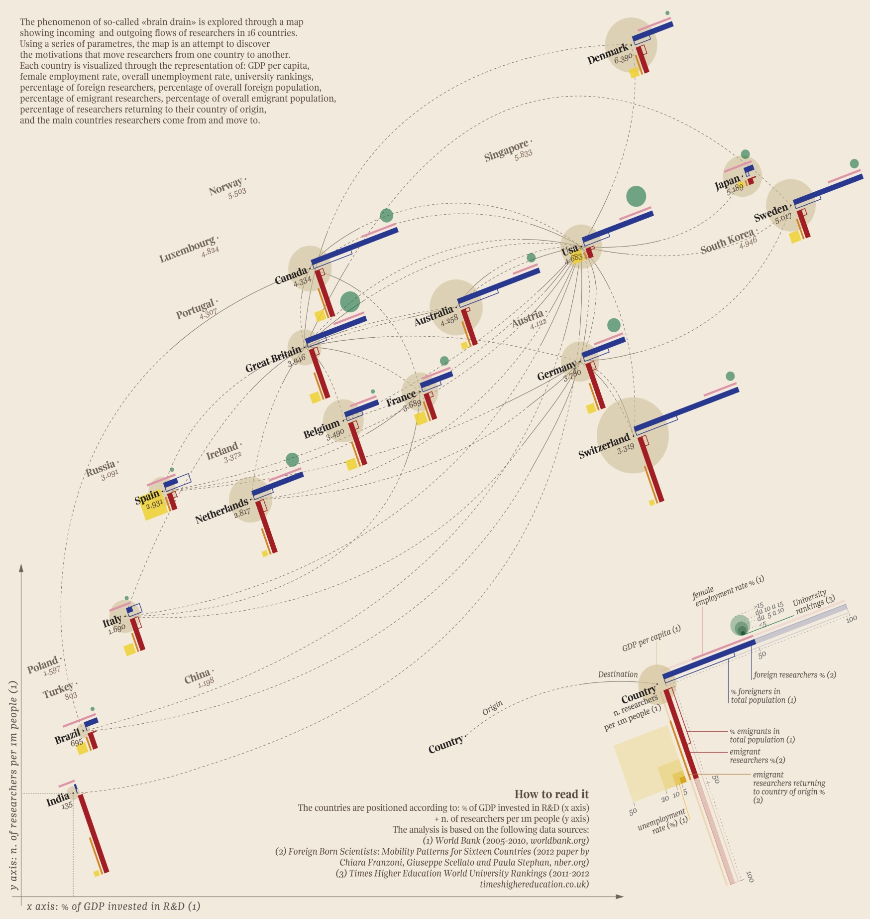Fig 1. “Brain Drain” for Selected Countries, Graph by Giorgia Lupi.

Works Cited

Lupi, Giorgia. “Brain Drain” A Visualization of Global “Brain Drain” in Science Inspired by

Abstract Art. Brain Pickings.org, 13 Feb. 2013.